
CnG Golden Affordability Experiment: Research Brief
May 2022 | Kelly Peterson Nithin AlexanderPriya Gandhi Danny Lo Yunyu Zhou

| Business Context & Research Questions: Cost is identified as one of the top barriers to entry for the New Vertical categories. A series of experiments are ongoing in the CnG sector to identify which levers DoorDash can pull to increase perceived affordability of DoorDash and ease customer frustrations around pricing. This research aims to understand:
- Have people noticed our pricing change?
- Can they explain what we changed?
- How do they feel about the change and how has their behavior changed?
- How do they expect their behavior to change in the future?

| Designs for reference: Figma File
Flat Fee: Inverse Fees: No Fees, Just Inflation
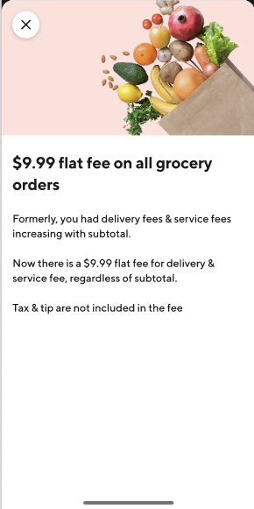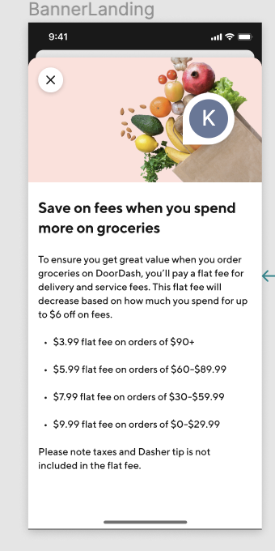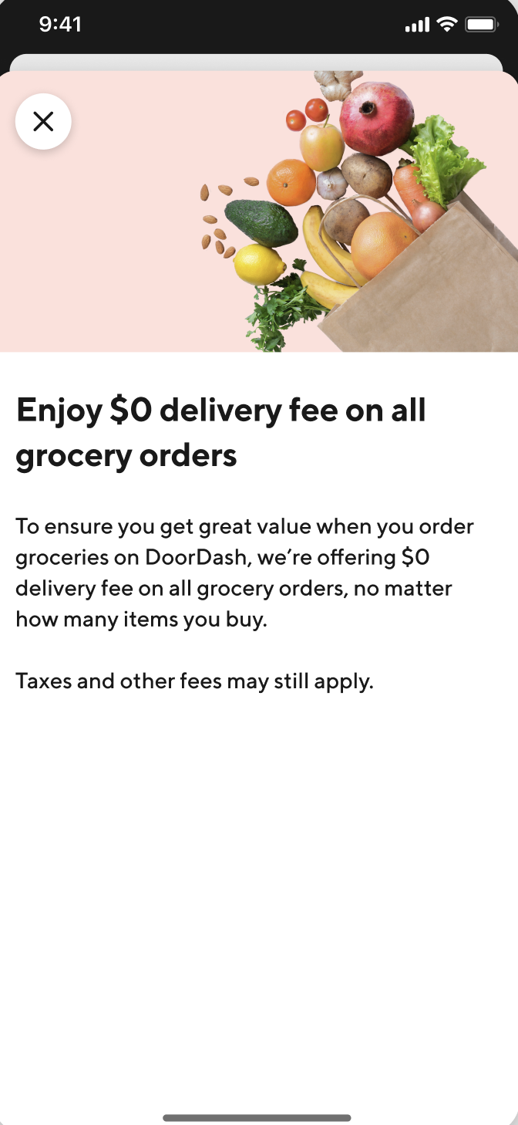

| Research Approach & Sample:
- Will recruit 16 Cx for 20 min 1:1 moderated sessions
- N= 4 Cx per each experiment
- Interviews will include a recall section and aided recall section
Cx list to be pulled: Danny Lo
- Customers invited to participate in the study will have recently been exposed to the experiments in a grocery store
- List should include the following variables
  - email
  - first_Name
  - last_Name
  - experiment viewed
  - customerID
Timing
Task | Responsible | Timing
Brief & Discussion Guide Completed | Kelly Peterson | 8/5
Cx List Pulled (see list description above) | Danny Lo | 8/12
Recruitment completed | Kelly Peterson | 8/15
Interviews | Kelly Peterson | 8/16-23
Report completed | Kelly Peterson | 8/23, Present on 8/24

| Interview schedule
CnG Golden Market Experiment UX Research Tracker

| Discussion Guide:
Please note: This is only a guide for the moderator. The interview will be most successful if conversational therefore, we may not ask every single question. Because this is based on recall I will follow the respondents lead.

INTRO | NOTE TO SELF: DON'T FORGET TO HIT RECORD  Thank you so much for taking the time to speak with me today. Today we are going to talk a bit about shopping on the app.  Before we get started it would be great if you could tell me a little bit about yourself and about your experience with DoorDash so far?  And tell me a little bit about your experience shopping for groceries on DoorDash? When did you first purchase on DoorDash? How frequently do you purchase on DoorDash? How much do you typically spend when shopping for groceries on DoorDash?
Recall | Awesome, now can you think about your most recent grocery shopping trip on DoorDash. Where was it?  - Was there anything different about this shopping trip compared to others?  - If mentioned pricing probe on what differences were  - If did not mention pricing ask if they noticed any significant difference in cost and then probe from there  - If did not mention pricing or notice difference in cost ask about promos or unique offerings and probe from there  - Thinking about some of the changes we’ve talked about, did you notice any differences in your shopping behaviors for this shopping trip?  - Do you feel this change is fair/beneficial to you/helpful/supportive of Cx? How does it make you feel about DoorDash?  - Do you feel like you spend more money, less money or the same amount that you typically do when shopping for groceries?  - How much did they spend  - If flat fees and under $30 ask what the use case was for this order (aka why they didn’t spend more money with 9.99 fee)  - Do you feel that the change we discussed will impact your future grocery shopping behaviors? How?
Aided Recall | Stimulus reminder  - Do you remember seeing this when shopping for groceries?  - Do you feel this change is fair/beneficial to you/helpful/supportive of Cx? How does it make you feel about DoorDash?  - Do you think this impacted your spending in any way? Do you think it will in the future?  - Do you think this would impact your frequency of shopping for groceries on DoorDash?

